On an **8x8** chessboard, there can be multiple Black Queens and one White King.

Given an array of integer coordinates queens that represents the positions of the Black Queens, and a pair of coordinates king that represent the position of the White King, return the coordinates of all the queens (in any order) that can attack the King.

**Example 1:**

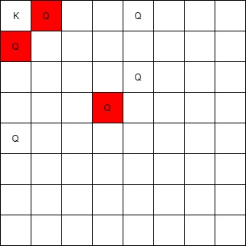

**Input:** queens = [[0,1],[1,0],[4,0],[0,4],[3,3],[2,4]], king = [0,0]

**Output:** [[0,1],[1,0],[3,3]]

**Explanation:**

The queen at [0,1] can attack the king cause they're in the same row.

The queen at [1,0] can attack the king cause they're in the same column.

The queen at [3,3] can attack the king cause they're in the same diagnal.

The queen at [0,4] can't attack the king cause it's blocked by the queen at [0,1].

The queen at [4,0] can't attack the king cause it's blocked by the queen at [1,0].

The queen at [2,4] can't attack the king cause it's not in the same row/column/diagnal as the king.

**Example 2:**

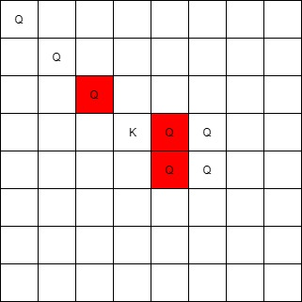

**Input:** queens = [[0,0],[1,1],[2,2],[3,4],[3,5],[4,4],[4,5]], king = [3,3]

**Output:** [[2,2],[3,4],[4,4]]

**Example 3:**

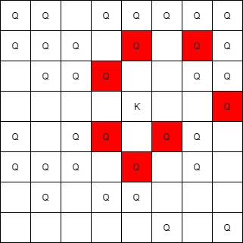

**Input:** queens = [[5,6],[7,7],[2,1],[0,7],[1,6],[5,1],[3,7],[0,3],[4,0],[1,2],[6,3],[5,0],[0,4],[2,2],[1,1],[6,4],[5,4],[0,0],[2,6],[4,5],[5,2],[1,4],[7,5],[2,3],[0,5],[4,2],[1,0],[2,7],[0,1],[4,6],[6,1],[0,6],[4,3],[1,7]], king = [3,4]

**Output:** [[2,3],[1,4],[1,6],[3,7],[4,3],[5,4],[4,5]]

**Constraints:**

* 1 <= queens.length <= 63
* queens[0].length == 2
* 0 <= queens[i][j] < 8
* king.length == 2
* 0 <= king[0], king[1] < 8
* At most one piece is allowed in a cell.